Letter of Medical Necessity Checklist
In the following document you will find a checklist and sample Letter of Medical Necessity. Please use this checklist as a guide while completing your patient’s individualized LOMN. You will need to customize and fill this out appropriately for each patient. Please note that all fields that require customizations are red and will need to be modified as the prescriber deems appropriate.
Please ensure the following are present on every Letter of Medical Necessity
- Patient First & Last Name
- Date of Birth
Patient’s Clinical History
- All pertinent diagnoses that convey the need for RELiZORB
- Include the diagnoses of “EPI”, “malabsorption”, “malnutrition”, if applicable
- Note the therapies tried, how they were administered (orally or added to formula), the name(s) of PERTs used and the evidence of treatment failure
- If RELiZORB trialed, please note symptom improvements, weight change, BMI change, if applicable
Treatment Plan
- Reference any additional guidelines, clinical studies tied to the patient’s clinical presentation
- Note number of cartridge(s) required
Summary
- Medical necessity criteria and hazards to health if continues a failed therapy
- For patients less than 2 years old, please be specific for rational for prescribing RELiZORB
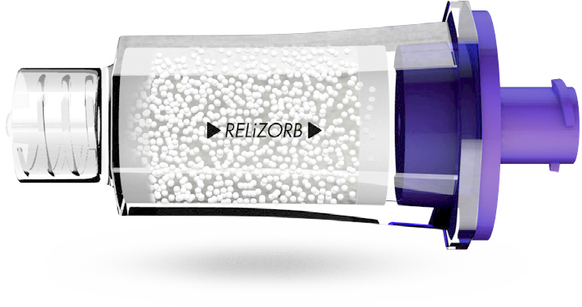
Attachments
Please include the following with the Prior Authorization packet
- Clinic visits in the last 6 months
- RD Nutrition notes from the last 6 months
- Growth charts – height, weight, BMI, weight for length (if applicable)

FOR ANY QUESTIONS: PLEASE CALL RELiZORB SUPPORT SERVICES AT 1-844-632-9271

Date:
Member Name:
Member DOB:
Member ID:

Dear Medical Director,

I am writing on behalf of my patient, <patient name>, to document medical necessity for treatment with RELiZORB® (iMMOBILIZED LIPASE) CARTRIDGE and request individual consideration of my patient’s case. This letter provides information about <patient name>’s clinical history and the evidence-based treatment plan I have prescribed. On behalf of my patient, I am requesting approval and subsequent payment for treatment with RELiZORB.

Patient's Clinical History
<Patient name> is a <age>-year-old <male/female> with history of cystic fibrosis, exocrine pancreatic insufficiency, <add additional pertinent diagnoses>, malabsorption and G tube dependency. <Patient name> had a G-tube placed <month, year> due to <feeding difficulties / poor weight gain / malnutrition / failure to thrive>. <Patient name>’s current BMI is in <____percentile>. The Cystic Fibrosis Foundation Guidelines recommend children 2-20 years old with cystic fibrosis be at or above a BMI in the 50th percentile as studies demonstrate a clear connection with improved pulmonary function (i).

Because <Patient name> has exocrine pancreatic insufficiency (EPI), <he/she> requires that pancreatic enzymes be present at all feedings, whether oral or enteral. In the past, <patient name> has received pancreatic enzyme replacement therapy (PERT) <method of enzyme delivery with tube feedings>. With this method of enzyme delivery, <patient name> suffers from < GI symptoms experienced>. Furthermore, despite optimizing enteral nutrition, <he/she> has been unable to achieve recommended BMI. <Patient name> has failed PERT therapy with enteral nutrition.

PERT products are intended for use with oral meals mostly consisting of solid foods, and there is no data regarding the safety and efficacy of PERT use with enteral nutrition. Patients receiving enteral nutrition were actually excluded from clinical trials which led to FDA approval of PERTs (i). Since <patient name> receives enteral nutrition overnight while sleeping, there is no practical, safe, effective way to deliver a pancreatic enzyme product during the overnight feeding outside of RELiZORB use.

Treatment Plan
RELiZORB is an FDA approved, single-use digestive enzyme cartridge designed to hydrolyze fats in enteral formula for individuals who require enteral nutrition and who do not excrete adequate amounts of the digestive enzyme lipase. RELiZORB connects in line with the feeding tube set and allows lipase to be present during the entire tube feeding process, hydrolyzing the fat in the enteral formula. As formula flows through the RELiZORB cartridge, the fats in the formula are broken down by the enzyme lipase and converted to readily absorbable fatty acids and monoglycerides.

Studies on RELiZORB published in peer-reviewed journals demonstrate the following (ii, iii, iv)
- Hydrolysis of fat in formula
- Normalization of plasma DHA/EPA fatty acid levels, (from <60% of normal at baseline to statistically significant improvements into the range of healthy individuals (2.8 fold improvement) (ii)
- Statistically significant 2.2 fold Improvement in red blood cell DHA and EPA composition a surrogate for longer term tissue uptake reaching levels found in healthy individuals. (iii)
  - This outcome is especially important for patients with CF as studies demonstrate a decrease in pulmonary exacerbations and antibiotic use associated with an increase in the absorption of essential fatty acids)
- Reduction in adverse gastrointestinal symptoms associated with EPI, across all studies (ii,iii,iv)
- Improved weight z-scores in 2 long-term studies [at 3 months (iii) and at 6 and 12 months (iv)].
- Statistically significant improvements in: weight, weight z-score and percentiles; height, height z-score and percentiles, at 6 months (iv).
- At 12 months, statistically significant improvements in height, weight and weight z-scores and a high trend towards clinically significant improvements in BMI z-score at 1 year (iv)
To ensure <patient name> is able to optimize absorption of the nutrients from enteral feedings, the treatment plan requires < # of cartridges> RELiZORB cartridges nightly with <his/her> enteral feedings. <Patient Name> will continue to receive PERTs orally with daytime meals.

Summary
If RELiZORB is not approved, this will put my patient at risk for <worsening GI disturbance, decreased appetite, further weight loss, dehydration, declining lung function and hospitalization.>

I strongly believe that RELiZORB is essential to <patient name>’s enteral feeding program. It is the only FDA approved treatment option to address <his/her> EPI and its debilitating, life-threatening effects. This device is medically necessary, widely accepted and the only clinically appropriate option for my patient’s current presentation.

If you have any questions, please do not hesitate to contact me. Thank you for your prompt attention to this matter.

Sincerely,

______________________

<MD name/title>

References:
- Schwarzenberg, S., et al. Enteral tube feeding for individuals with cystic fibrosis: CFF evidence-informed guidelines. Journal of Cystic Fibrosis. 2016; 724-735.
- Freedman, S., et al. Increased fat absorption from enteral formula through an in-line digestive cartridge in patients with cystic fibrosis. J Pediatr Gastroenterol Nutr. 2017;65(1):97-101.
- Stevens J, Wyatt C, Brown P, Patel D, Grujic D, Freedman SD. Absorption and Safety with Sustained Use of RELiZORB® Evaluation (ASSURE) study in patients with cystic fibrosis receiving enteral feeding. J Pediatr Gastroenterol Nutr. 2018; 67(4):527-532.
- Sathe, M., Patel, D., Stone, A., First, E. Evaluation of the effectiveness of in-line immobilized lipase cartridge in enterally fed patients with cystic fibrosis. J Pediatr Gastroenterol Nutr. 2021;72:18-23.
- Hanssens L, Theibaut I, Lefevre N, et al. The clinical benefits of long-term supplementation with omega-3 fatty acids in cystic fibrosis patients – a pilot study. Prostaglandins Leuko Essent Fatty Acids 2016; 108:45-50.
- DeVizia B, Raia V, Spano C, et al. Effect of an 8-month treatment with omega 3 fatty acids (eicosapentaenoic and docosahexaenoic) in patients with cystic fibrosis. J Parenter Enteral Nutr
2003; 27:52-57.

